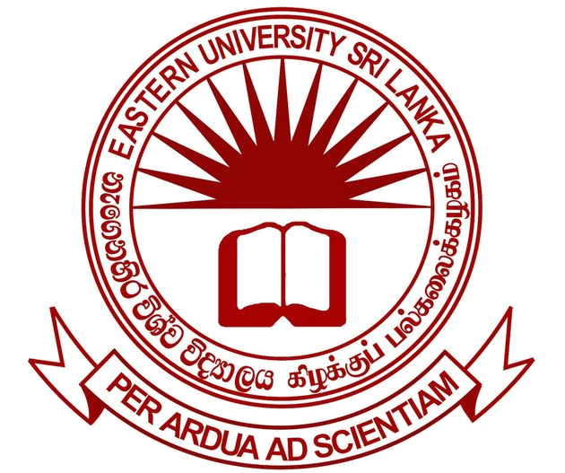

EASTERN UNIVERSITY, SRI LANKA
VACANCY

The Eastern University, Sri Lanka will entertain applications from suitably qualified persons for the following post.
POST OF SENIOR ASSISTANT INTERNAL AUDITOR
(ON CONTRACT - SECONDMENT BASIS)

Qualifications:

- (a) Should possess a pass in the final examination of the Institute of Chartered Accountants of Sri Lanka or its equivalent

OR

(b) Should possess a Degree from a recognised University/HEI and a Certificate of Intermediate Level of the Institute of Chartered Accountants of Sri Lanka or its equivalent.

AND

- At least three (03) years of experience in Accounting and/or Auditing in an executive capacity after acquiring the qualifications 1 (a) or 1(b) above.

Note: Preference will be given to those who have experience in Accounting and Auditing in a State Organization.

Duration: One year (extendable)

Salary Code & Scale: U-EX 2(II) as at 01.01.2020 – Rs.66,180 - 8 x 1,335; 8x1,630 - 89,900 p.m

- The other allowances determined by the University Grants Commission will be paid in addition on the above salary.
- Those who are released on secondment basis will be paid the monthly salary as per the existing regulations.

Closing date: 05.08.2022

HOW TO APPLY

Curriculum Vitae (CV) along with certified copies of academic and professional qualifications with service certificates should be forwarded via email to sar_ae@esn.ac.lk and the hard copy could be sent under the registered cover to reach the “ Senior Assistant Registrar, Establishments Department (Academic Division), Eastern University, Sri Lanka, Vanthrumoolai, Chenkalady” on or before the closing date.

The post applied for should be indicated on the top left corner of the envelop.

Applicants who are employees of Government Departments, State Corporations and Statutory Bodies should forward their applications through the Head of their respective institutions, but may send an advance copy in the first instance. However, no such applicant will be considered for appointment, if the application channelled through the Head of the Department is not received.

The University reserves the right to short list and interview only such applicants as the University may consider suitable for appointment.

REGISTRAR
EASTERN UNIVERSITY, SRI LANKA
VANTHARUMOOLAI
CHENKALADY
18.07.2022

