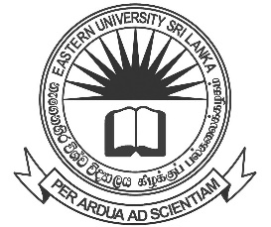

EASTERN UNIVERSITY, SRI LANKA
NOTICE
COLLECTION OF DEGREE CERTIFICATES (EXTERNAL GRADUANDS)

External Graduands of the following Degree Programmes who were conferred degrees on 05.02.2021, can collect their Degree Certificates from the Academic Affairs Department, by producing their External Student Identity Card.

- Bachelor of Science (External)
- Bachelor of Business Administration (External)
- Bachelor of Science in Management (External)

Note: Graduands are requested in person to collect their Degree Certificates. Degree Certificates will not be issued to another person.

Mrs. N. Nirumithan
Senior Assistant Registrar/ Academic Affairs Department
for Registrar

12.11.2021

