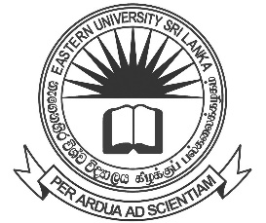

EASTERN UNIVERSITY, SRI LANKA
NOTICE

COLLECTION OF DEGREE CERTIFICATES
FACULTY OF COMMERCE & MANAGEMENT

Bachelor of Business Administration, Bachelor of Commerce, Bachelor of Business Administration (External) graduates, who were conferred degrees on 05.02.2021, can collect their Degree Certificates from the Academic Affairs Department on 22.04.2021 and 23.04.2021 from 10.00 a.m. to 4.00 p.m. by producing their Student Identity Card and Students Record Book.

- Graduands are requested in person to collect their Degree Certificates. Degree Certificates will not be issued to another person.

- Degree Certificates will be issued to those who completed the No-Claim with the respective Faculty.

Mrs. N. Nirumithan
Senior Assistant Registrar/ Academic Affairs Department
for Registrar

09.04.2021

